**Supplementary Material**

**Virologica Sinica**

**The Continued Evolution of the H10N3 Influenza Virus with Adaptive Mutations Poses an Increased Threat to Mammals**

Shiping Ding a, b, c, d, 1, Jiangtao Zhou a, b, c, d, 1, Junlong Xiong a, b, c, d, Xiaowen Du g, Wenzhuo Yang a, b, c, d,

Jinyu Huang a, b, c, d, Yi Liu a, b, c, d, Lihong Huang a, b, c, d, Ming Liao b, c, d, e, g, Jiahao Zhang f, *, Wenbao Qi a, b, c, d, e, *

a State Key Laboratory for Animal Disease Control and Prevention, South China Agricultural University, Guangzhou, 510642, China.

b National Avian Influenza Para-Reference Laboratory, Guangzhou, 510642, China.

c Key Laboratory of Zoonoses, Ministry of Agriculture and Rural Affairs, Guangzhou, 510642, China.

d National and Regional Joint Engineering Laboratory for Medicament of Zoonoses Prevention and Control, Guangzhou, 510642, China.

e Key Laboratory of Zoonoses Prevention and Control of Guangdong Province, Guangzhou, 510642, China.

f State Key Laboratory of Agricultural Microbiology, College of Veterinary Medicine, Huazhong Agricultural University, Wuhan, 430070, China.

g College of Animal Science and Technology, Zhongkai University of Agriculture and Engineering, Guangzhou, 510550, China.

**1** Shiping Ding, Jiangtao Zhou contributed equally to the authors.

\***Correspondence**:

E-mail addresses: qiwenbao@scau.edu.cn (W. Qi); jiahaozhang@hzau.edu.cn (J. Zhang)

ORCID: 0000-0003-0610-7506 (W. Qi); 0000-0002-8780-1497 (J. Zhang)

**Supplementary Figure S1.** Phylogenetic analysis of the internal genes (PB2, PB1, PA, NP, M, NS) of H10 subtype influenza viruses.

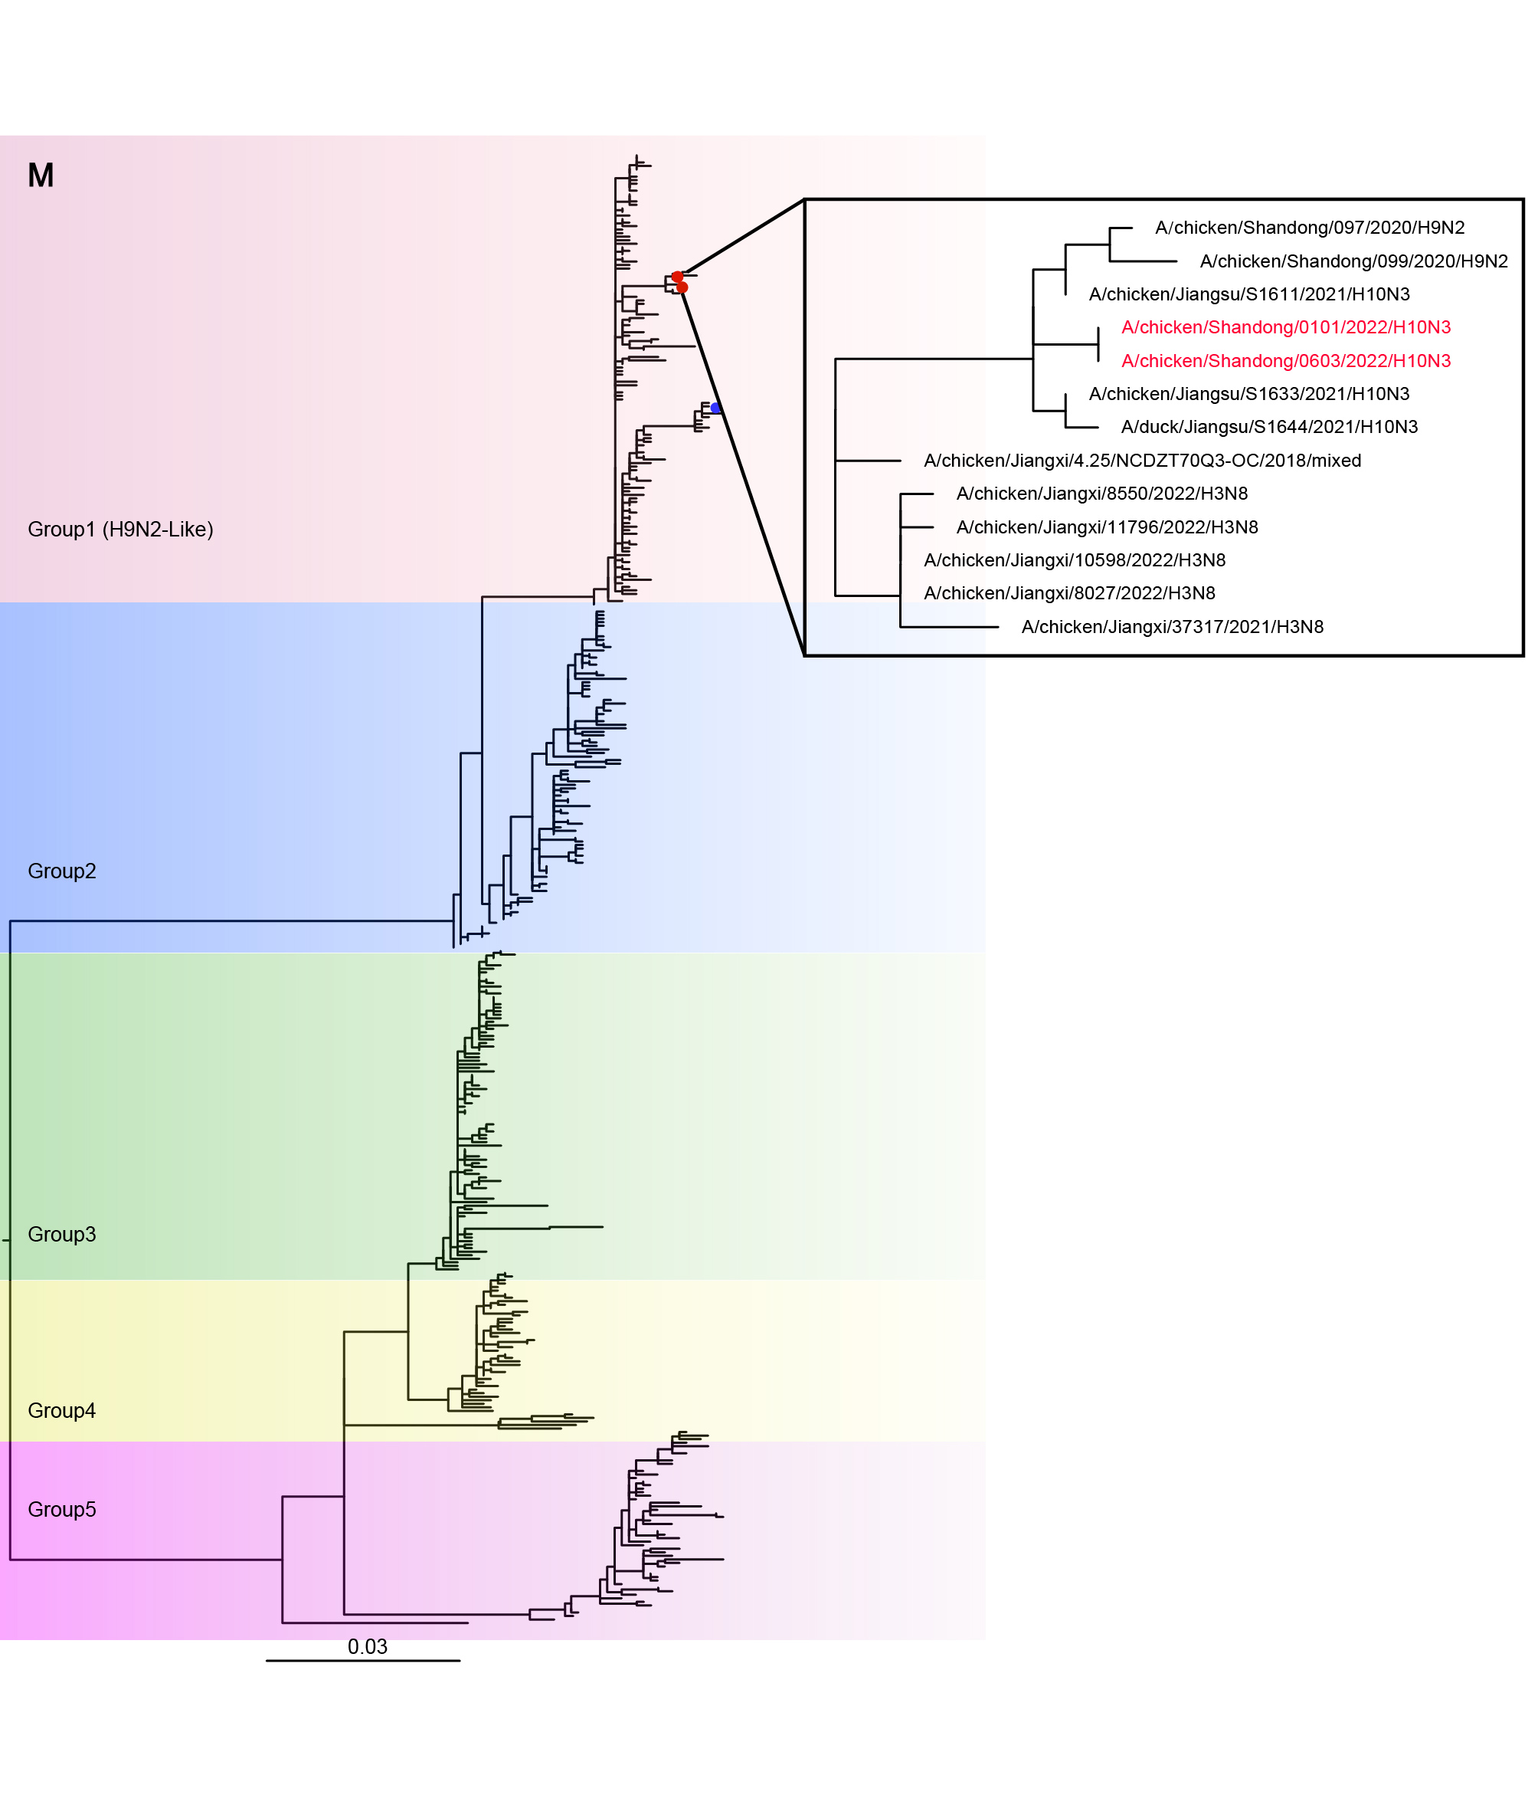

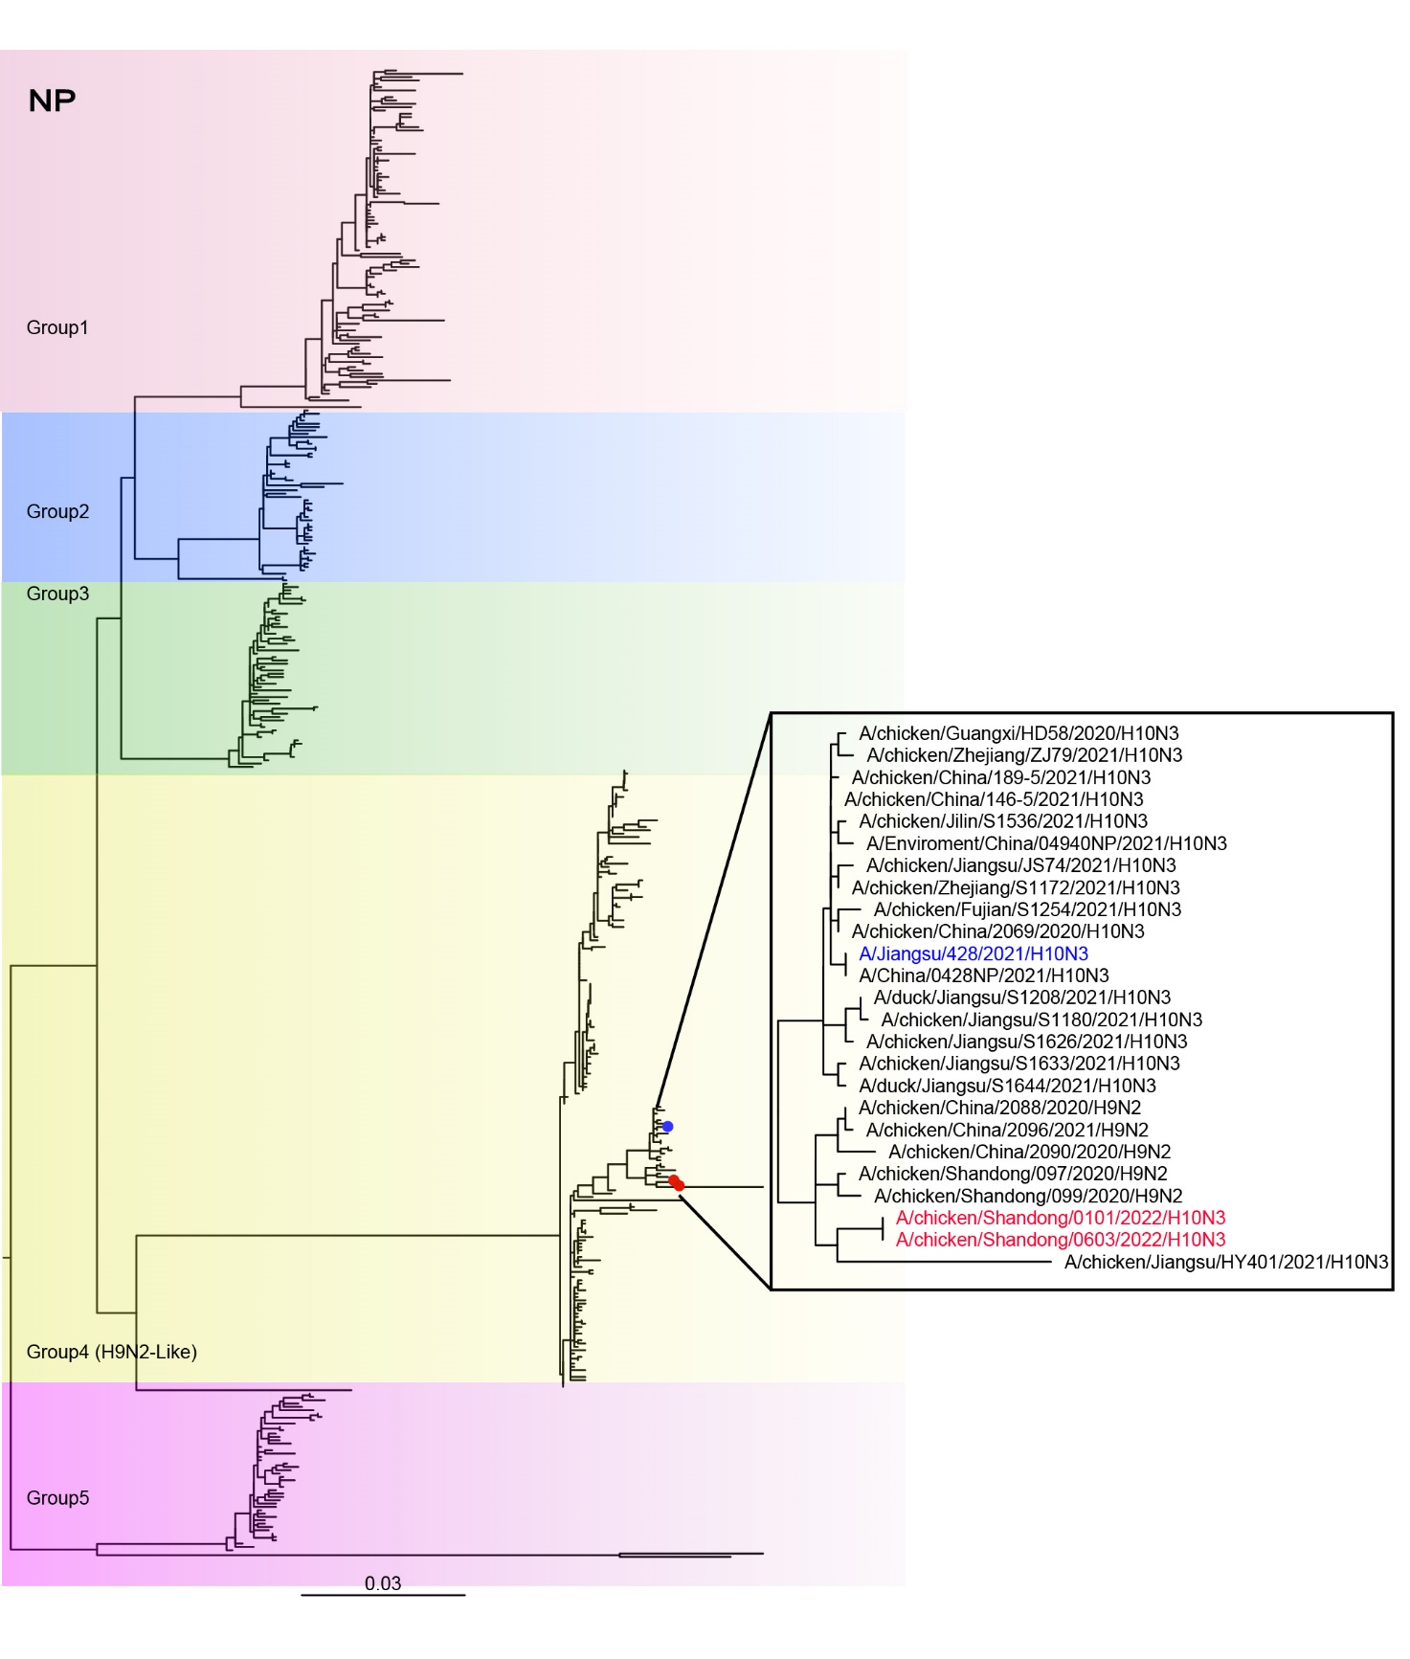

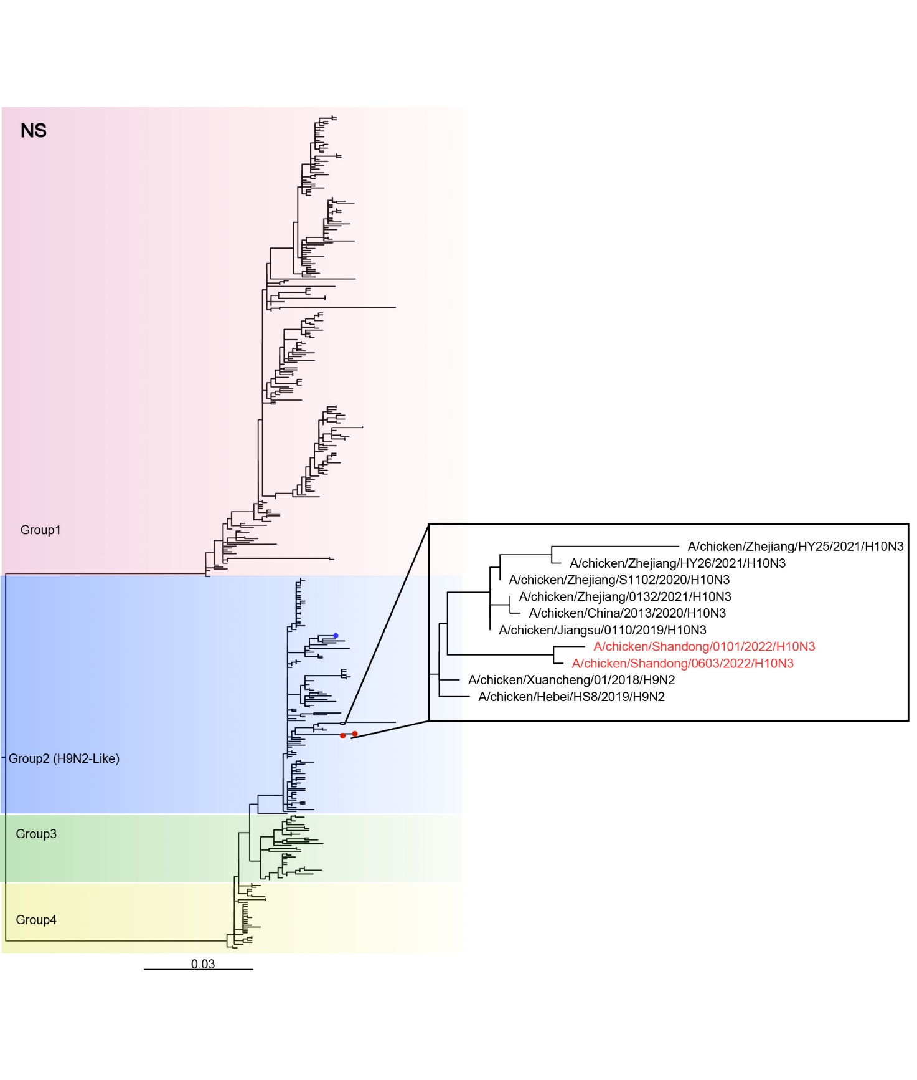

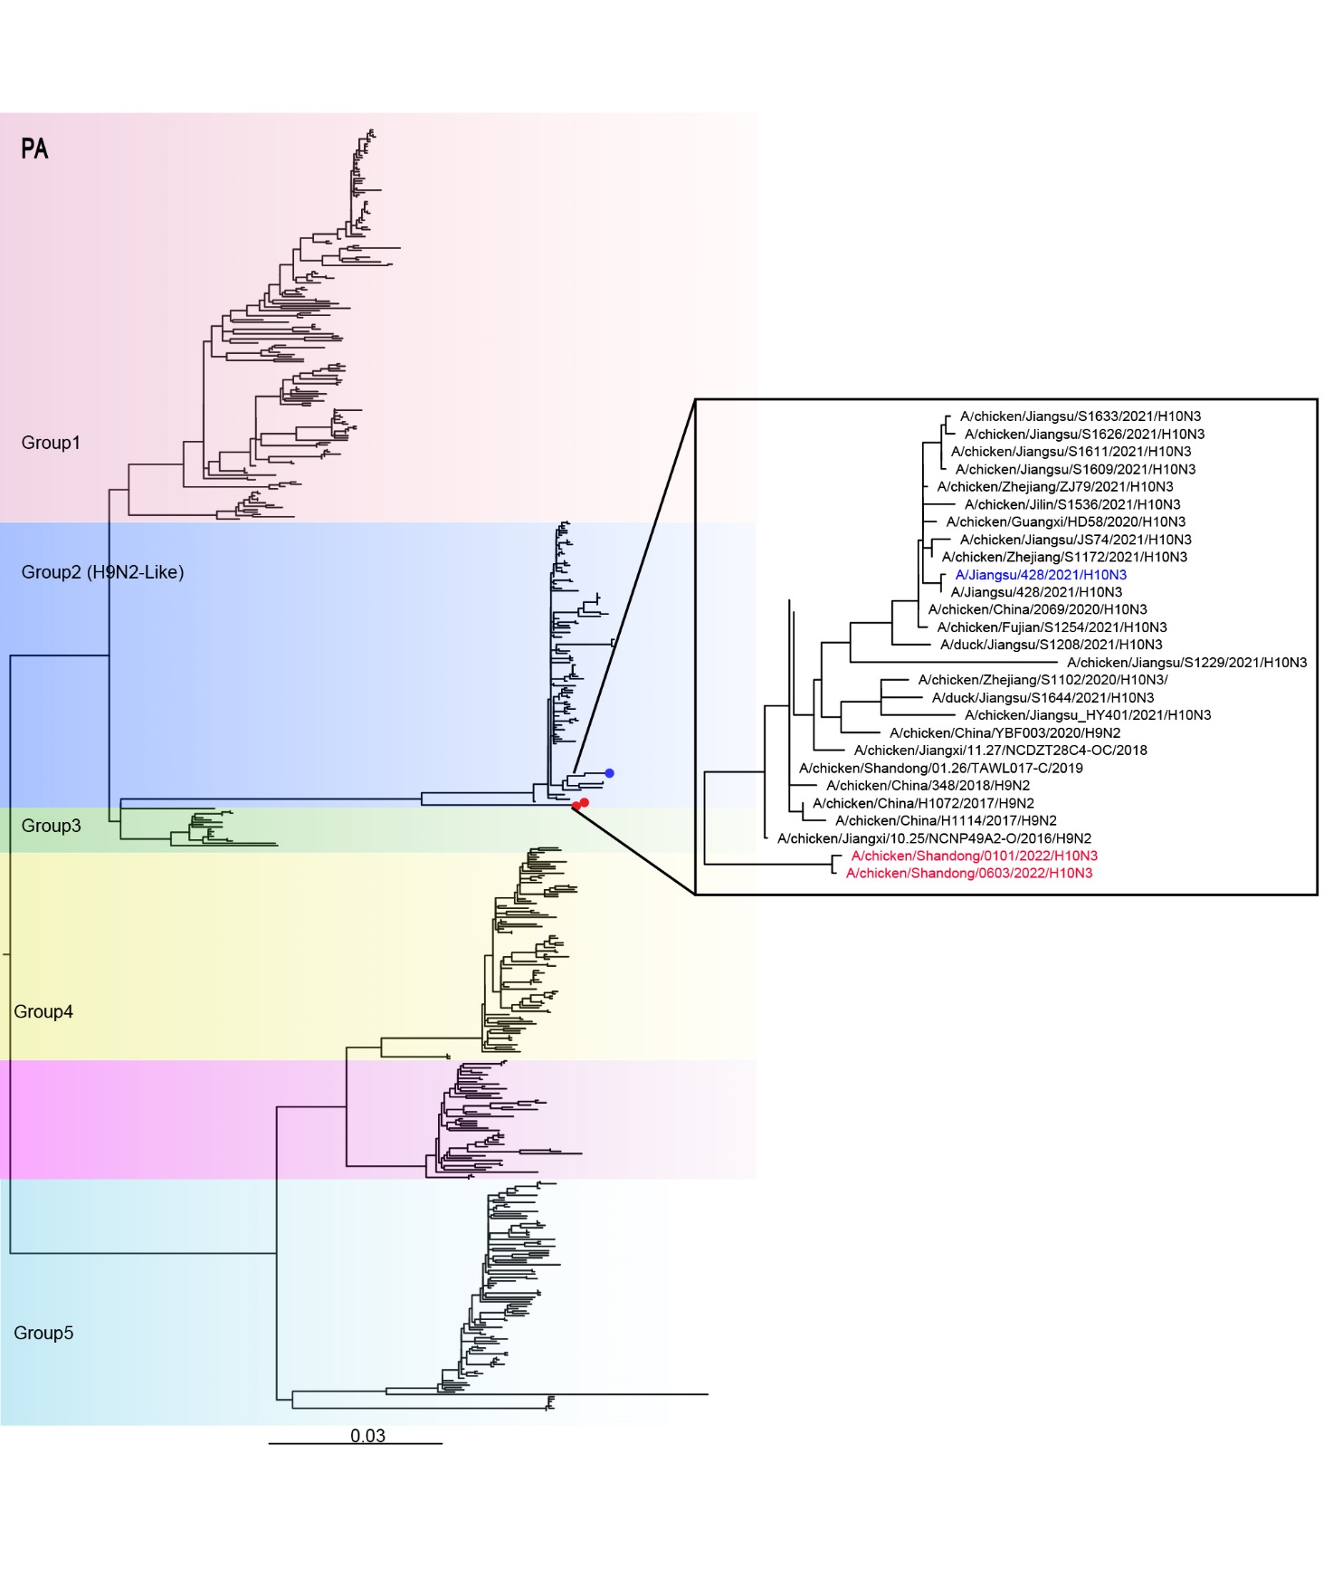

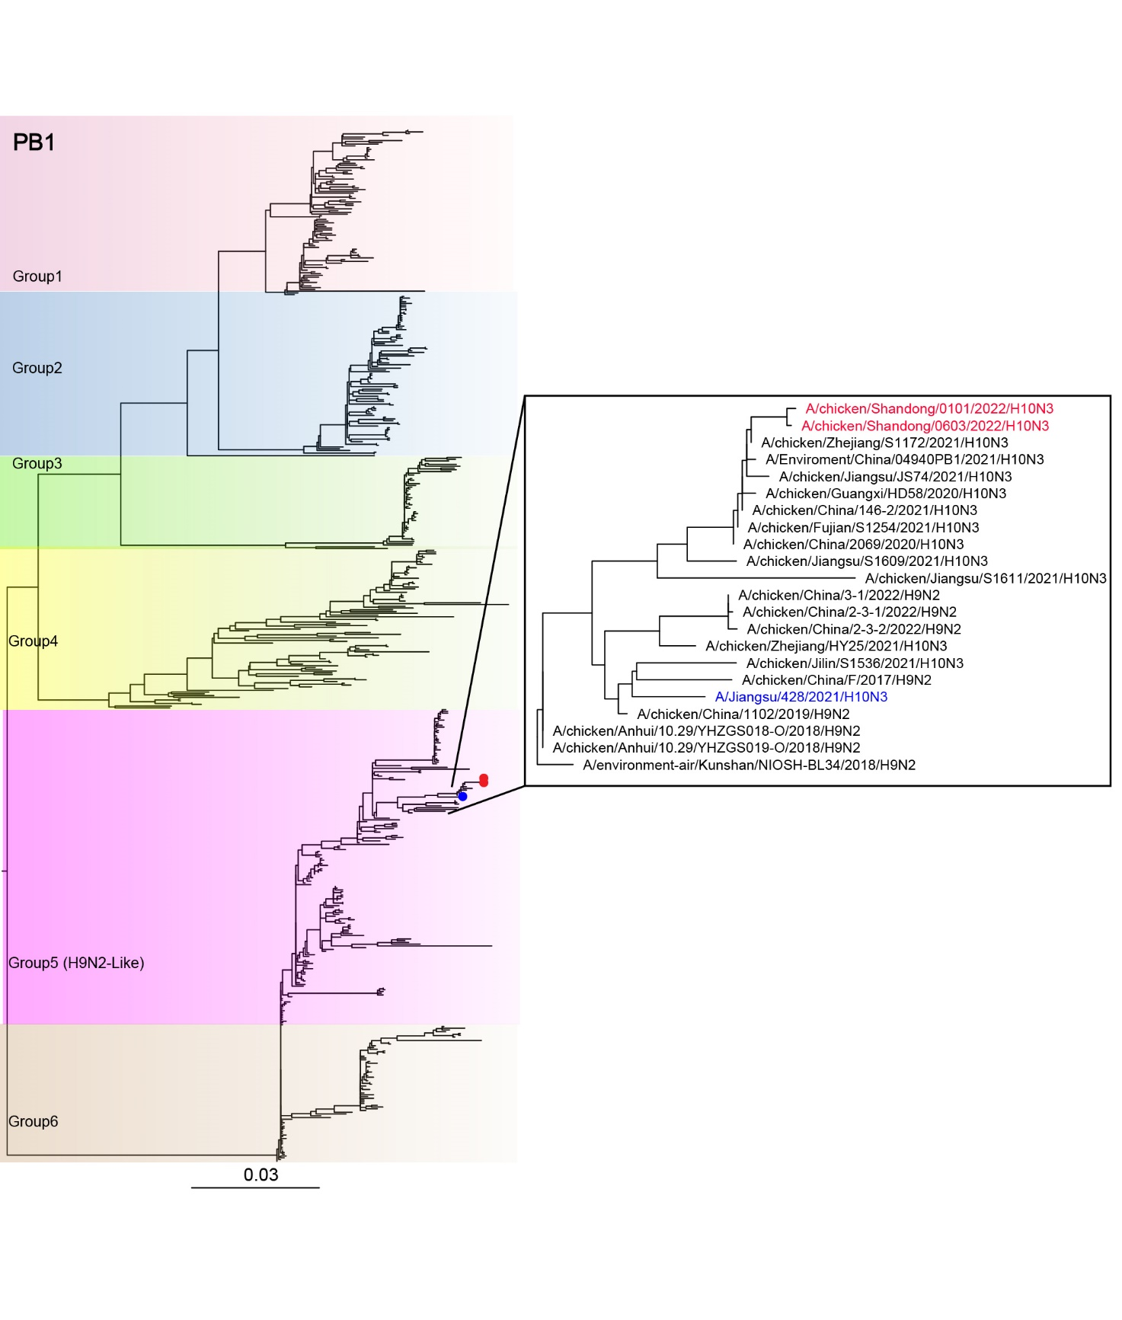

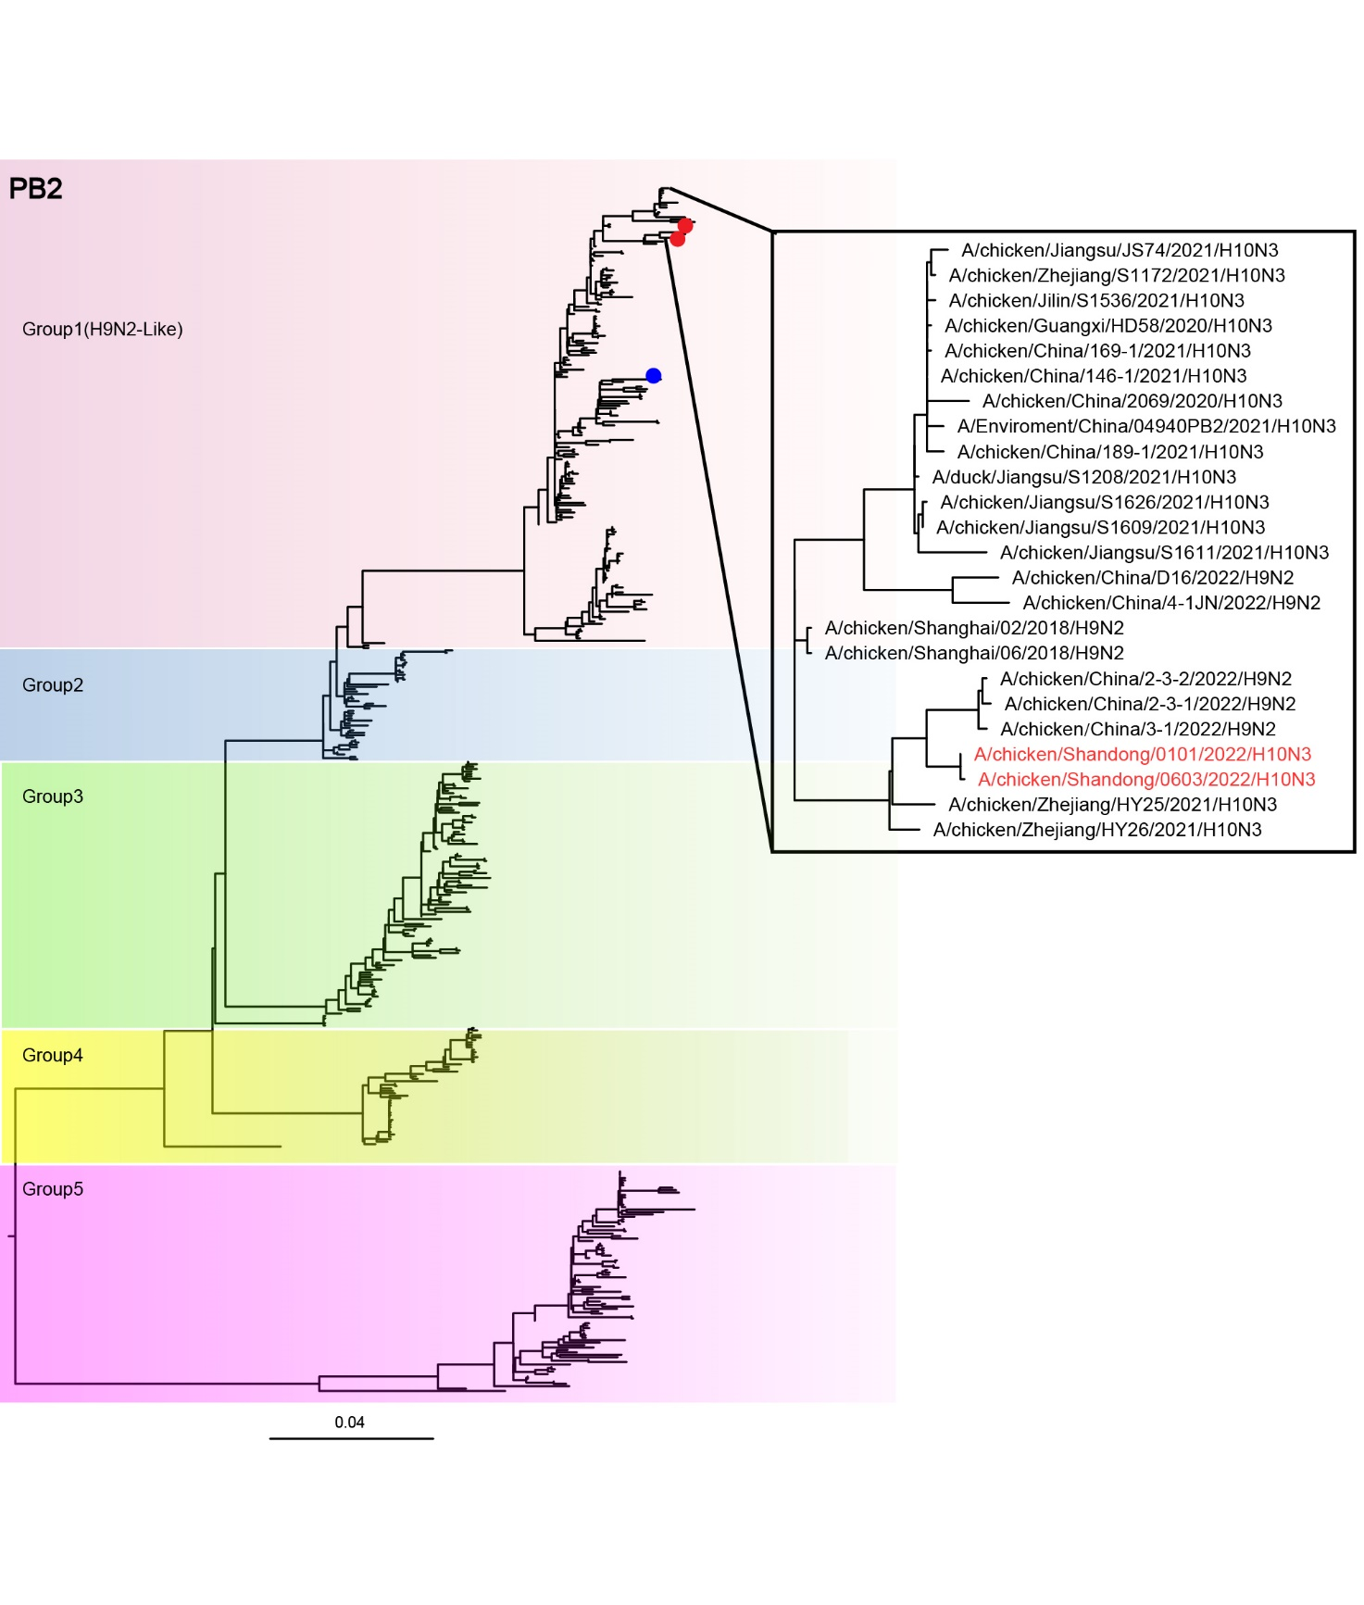

**Supplementary Figure S2.** Provinces in China where the H10N3 virus is concentrated. **A** Percentage distribution of all H10N3 viruses isolated in China. **B** Percentage distribution of novel H10N3 viruses isolated in China.

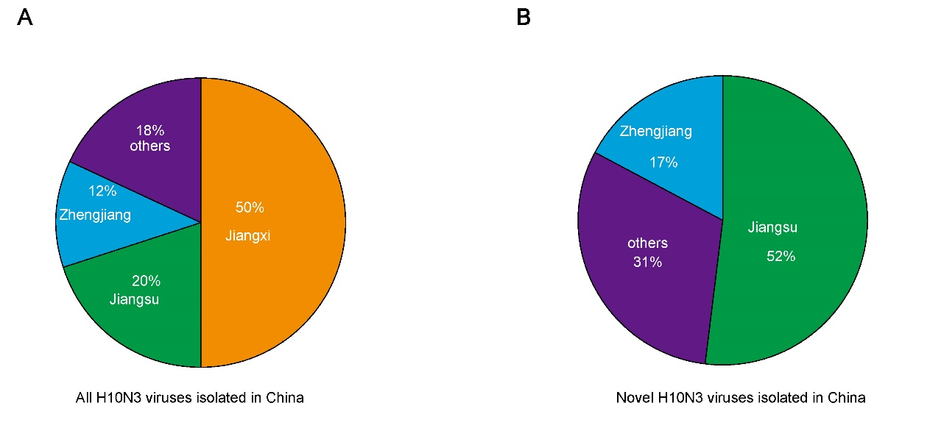

**Supplementary Table S1.** Supplementary references on adaptive mutations in this study.

|  |  |  |  |
| --- | --- | --- | --- |
| Protein | Mutation | Function | Reference |
| HA | Q222R | Unknown |  |
| (H3 numbering) | G228S | Increased virus binding to α2–6 | Song et al., 2017 |
|  | Q226L | Increased virus binding to α2–6 | Qu et al., 2017 |
| Cleavage site | | Only one basic amino acid at the HA cleavage site, which is a characteristic of low-pathogenicity AIV in chicken | Zohari et al., 2014 |
| PB2 | E627K | Mammalian adaptive markers | Sediri et al., 2016 |
| D701N | Yu et al., 2019 |
| I292V | Suttie et al., 2019 |
| A588V | Suttie et al., 2019 |
| PB1 | I368V | Improved the polymerase activity and virulence in mammals | Guo et al., 2022 |
| S375N |
| PA | A343S | Increased the replication of viruses in mammalian cells and pathogenicity in mice | Yamaji et al., 2015 |
| K356R | Xu et al., 2016 |
| N409S | Yamayoshi et al., 2014 |
| M1 | N30D | Increased virulence in mice | Fan et al., 2009 |
| T215A |
| M2 | S31N | Resistance to adamantanes | Lan et al., 2010 |

PB, basic polymerase; PA, acidic polymerase; HA, hemagglutinin; NP, nucleoprotein; NA, neuraminidase; M, matrix protein; NS, nonstructural protein.

0101, A/chicken/Shandong/0101/2022; 0603, A/chicken/Shandong/0603/2022; 0428, A/Jiangsu/0428/2021.

**Reference**

Fan, S., Deng, G., Song, J., Tian, G., Suo, Y., Jiang, Y., Guan, Y., Bu, Z., Kawaoka, Y., Chen, H., 2009. Two amino acid residues in the matrix protein M1 contribute to the virulence difference of H5N1 avian influenza viruses in mice. Virology 384, 28–32.

Guo, Y., Ding, P., Li, Y., Zhang, Y., Zheng, Y., Yu, M., Suzuki, Y., Zhang, H., Ping, J., 2022. Genetic and biological properties of H10N3 avian influenza viruses: A potential pandemic candidate?. Transbound Emerg Dis. 69, e3171–e3182.

Lan, Y., Zhang, Y., Dong, L., Wang, D., Huang, W., Xin, L., Yang, L., Zhao, X., Li, Z., Wang, W., Li, X., Xu, C., Yang, L., Guo, J., Wang, M., Peng, Y., Gao, Y., Guo, Y., Wen, L., Jiang, T., Shu Y.A., 2010. A comprehensive surveillance of adamantane resistance among human influenza A virus isolated from mainland China between 1956 and 2009. Antivir Ther. 15, 853–859.

Qu, Z., Ma, S., Kong, H., Deng, G., Shi, J., Liu, L., Suzuki, Y., Chen, H., 2017. Identification of a key amino acid in hemagglutinin that increases human-type receptor binding and transmission of an H6N2 avian influenza virus. Microbes Infect. 19, 655–660.

Sediri, H., Thiele, S., Schwalm, F., Gabriel, G., Klenk, H. D., 2016. PB2 subunit of avian influenza virus subtype H9N2: a pandemic risk factor. J Gen Virol. 97, 39–48.

Song, H., Qi, J., Xiao, H., Bi, Y., Zhang, W., Xu, Y., Wang, F., Shi, Y., Gao, G. F., 2017. Avian-to-Human Receptor-Binding Adaptation by Influenza A Virus Hemagglutinin H4. Cell Rep. 20, 1201–1214.

Suttie, A., Deng, Y. M., Greenhill, A. R., Dussart, P., Horwood, P. F., Karlsson, E. A., 2019. Inventory of molecular markers affecting biological characteristics of avian influenza A viruses. Virus Genes 55, 739–768.

Xu, G., Zhang, X., Gao, W., Wang, C., Wang, J., Sun, H., Sun, Y., Guo, L., Zhang, R., Chang, K. C., Liu, J., Pu, J., 2016. Prevailing PA Mutation K356R in Avian Influenza H9N2 Virus Increases Mammalian Replication and Pathogenicity. J Virol. 90, 8105–8114.

Yamaji, R., Yamada, S., Le, M. Q., Ito, M., Sakai-Tagawa, Y., Kawaoka, Y., 2015. Mammalian adaptive mutations of the PA protein of highly pathogenic avian H5N1 influenza virus. J Virol. 89, 4117–4125.

Yamayoshi, S., Yamada, S., Fukuyama, S., Murakami, S., Zhao, D., Uraki, R., Watanabe, T., Tomita, Y., Macken, C., Neumann, G., Kawaoka, Y., 2014. Virulence-affecting amino acid changes in the PA protein of H7N9 influenza A viruses. J Virol, 88, 3127–3134.

Yu, Z., Ren, Z., Zhao, Y., Cheng, K., Sun, W., Zhang, X., Wu, J., He, H., Xia, X., Gao, Y., 2019. PB2 and hemagglutinin mutations confer a virulent phenotype on an H1N2 avian influenza virus in mice. Arch Virol. 164, 2023–2029.

Zohari, S., Neimanis, A., Härkönen, T., Moraeus, C., Valarcher, J. F., 2014. Avian influenza A(H10N7) virus involvement in mass mortality of harbour seals (Phoca vitulina) in Sweden, March through October 2014. Euro Surveill. 19, 20967.